February 25^{th,} 2024 Vol. I Issue 36
REDEMPTION EVANGELICAL LUTHERAN CHURCH AND SCHOOL
2nd Sunday in Lent

WELCOME To all of you who are visiting our service this morning, we extend a most cordial welcome in Jesus’ name. It is our hope that you will feel at home in our midst and will be blessed by our message of Christ crucified and risen for the sins of the world.

If you are looking for a church home or would like to know more about our beliefs and practices, please see the pastor. He will be glad to visit with you at your convenience. Be sure to join us again.

Member of the Church of the Lutheran Confession
20120 24th Ave W Lynnwood, WA 98036
Redemptionclc.com
Pastor Jonah Albrecht
Personal: (507) 329-2641
Office: (425)-775-2145
Teacher Quinn Sprengeler
(425) 582-1381
President Scott Prior
(425) 231-8600
skbprior@gmail.com
Pre-Service Meditation:
Genesis 17:7 And I will establish my covenant between me and you and your offspring after you throughout their generations for an everlasting covenant, to be God to you and to your offspring after you.
Prayer: Oh, Heavenly Father, You made a covenant with Abraham in which You promised to bless him abundantly. You have made us the recipients of this same covenant through faith in Christ. May You continue to fulfill this covenant for your people today. Through Jesus Christ, Your Son, who lives and reigns with You and the Holy Spirit forevermore, Amen.
Service of the Word
Opening Prayer

Opening Hymn WS 748 Praise to the Lord, the Almighty

Confession and Absolution
P: In the name of the Father and of the T Son and of the Holy Spirit.
C: Amen.

P: Beloved in the Lord! Let us draw near with a true heart and confess our sins unto God our Father, beseeching Him in the name of our Lord Jesus Christ to grant us forgiveness.

P: Our help is in the name of the Lord,
C: who made heaven and earth.
P: I said, I will confess my transgressions unto the Lord,
C: and You forgave the iniquity of my sin.

P : Almighty God, our maker and redeemer, we poor sinners confess unto You that we are by nature sinful and unclean and that we have sinned against You by thought, word, and deed. Wherefore we flee for refuge to Your infinite mercy, seeking and imploring Your grace for the sake of our Lord Jesus Christ.

C: O most merciful God, who has given Your only-begotten Son to die for us, have mercy upon us and for His sake grant us remission of all our sins; and by Your Holy Spirit increase in us true knowledge of You and of Your will and true obedience to Your Word, to the end that by Your grace we may come to everlasting life; through Jesus Christ, our Lord. Amen.

P: Upon this your confession, I, as a called servant of the Word, announce the grace of God unto all of you, and in the stead and by the command of my Lord Jesus Christ I forgive you all your sins in the name of the Father and of the T Son and of the Holy Spirit.
C: Amen.

Gloria Patri TLH pg 6
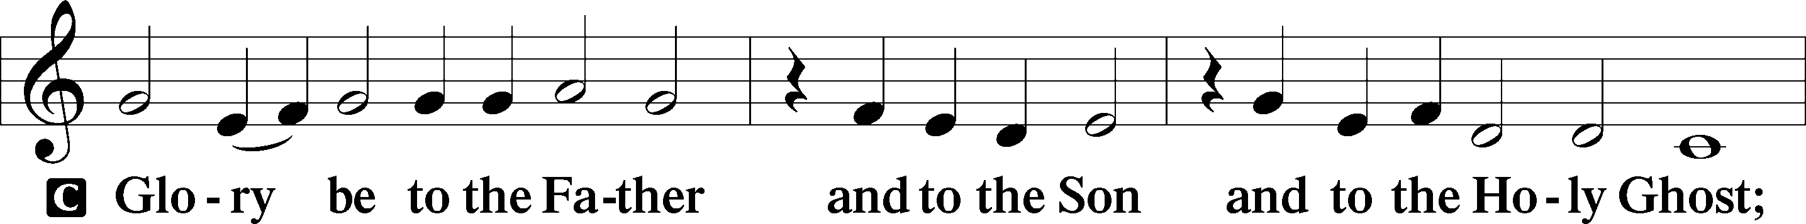

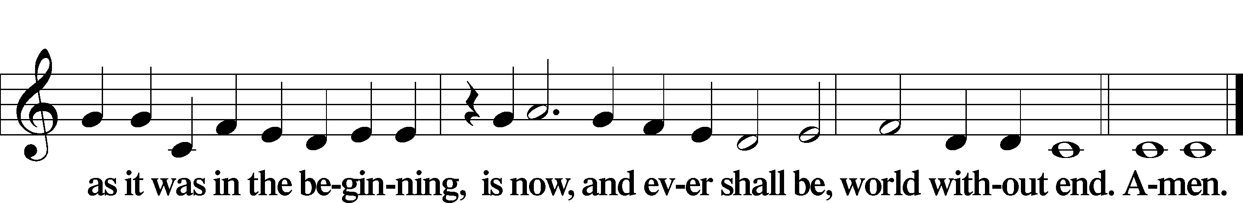

Kyrie TLH pg 7
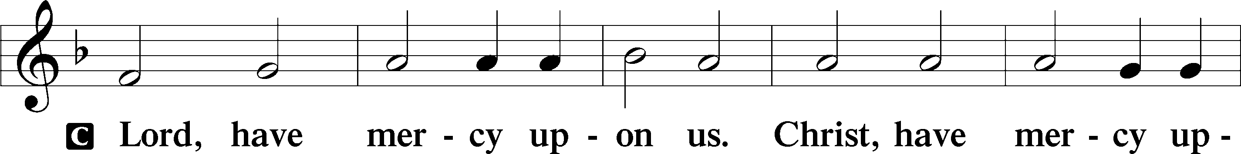

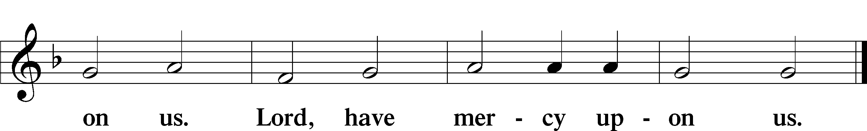

Hymn of Praise: TLH 237 ♫♫
All glory be to God on high,
Who hath mankind befriended!
To us no harm shall now come nigh,
The strife at last is ended;
God showeth His good will to men,
And peace shall reign on earth again;
Oh, thank Him for His goodness!
Salutation and Collect of the Day
P Let us pray. . .
. . . through Jesus Christ our Lord, who lives and reigns with You and the Holy Spirit, one God, now and forever.
C Amen.

Old Testament Lesson Genesis 17:1-7; 15-16

¹When Abram was ninety-nine years old the LORD appeared to Abram and said to him, "I am God Almighty; walk before me, and be blameless, ² that I may make my covenant between me and you, and may multiply you greatly." ³ Then Abram fell on his face. And God said to him, ⁴ "Behold, my covenant is with you, and you shall be the father of a multitude of nations. ⁵ No longer shall your name be called Abram, but your name shall be Abraham, for I have made you the father of a multitude of nations. ⁶ I will make you exceedingly fruitful, and I will make you into nations, and kings shall come from you. ⁷ And I will establish my covenant between me and you and your offspring after you throughout their generations for an everlasting covenant, to be God to you and to your offspring after you.”. . . .And God said to Abraham, "As for Sarai your wife, you shall not call her name Sarai, but Sarah shall be her name. ¹⁶ I will bless her, and moreover, I will give you a son by her. I will bless her, and she shall become nations; kings of peoples shall come from her."

Psalm of the Day Psalm 5 (selected verses)
P You who fear the Lord, praise him!
All you offspring of Jacob, glorify him,
C and stand in awe of him, all you offspring of Israel!
P For he has not despised or abhorred
the affliction of the afflicted,
C and he has not hidden his face from him,
but has heard, when he cried to him.
P All the ends of the earth shall remember
and turn to the Lord,
C and all the families of the nations
shall worship before you.
P Posterity shall serve him;
it shall be told of the Lord to the coming generation;
C they shall come and proclaim his righteousness to a people yet unborn, that he has done it.
Epistle Lesson Romans 5:1-11
¹Therefore, since we have been justified by faith, we have peace with God through our Lord Jesus Christ. ² Through him we have also obtained access by faith into this grace in which we stand, and we rejoice in hope of the glory of God. ³ Not only that, but we rejoice in our sufferings, knowing that suffering produces endurance, ⁴ and endurance produces character, and character produces hope, ⁵ and hope does not put us to shame, because God's love has been poured into our hearts through the Holy Spirit who has been given to us. ⁶ For while we were still weak, at the right time Christ died for the ungodly. ⁷ For one will scarcely die for a righteous person-- though perhaps for a good person one would dare even to die-- ⁸ but God shows his love for us in that while we were still sinners, Christ died for us. ⁹ Since, therefore, we have now been justified by his blood, much more shall we be saved by him from the wrath of God. ¹⁰ For if while we were enemies we were reconciled to God by the death of his Son, much more, now that we are reconciled, shall we be saved by his life. ¹¹ More than that, we also rejoice in God through our Lord Jesus Christ, through whom we have now received reconciliation.

Gospel Lesson Mark 8:27-37
²⁷ And Jesus went on with his disciples to the villages of Caesarea Philippi. And on the way he asked his disciples, "Who do people say that I am?" ²⁸ And they told him, "John the Baptist; and others say, Elijah; and others, one of the prophets." ²⁹ And he asked them, "But who do you say that I am?" Peter answered him, "You are the Christ." ³⁰ And he strictly charged them to tell no one about him. ³¹ And he began to teach them that the Son of Man must suffer many things and be rejected by the elders and the chief priests and the scribes and be killed, and after three days rise again. ³² And he said this plainly. And Peter took him aside and began to rebuke him. ³³ But turning and seeing his disciples, he rebuked Peter and said, "Get behind me, Satan! For you are not setting your mind on the things of God, but on the things of man." ³⁴ And calling the crowd to him with his disciples, he said to them, "If anyone would come after me, let him deny himself and take up his cross and follow me. ³⁵ For whoever would save his life will lose it, but whoever loses his life for my sake and the gospel's will save it. ³⁶ For what does it profit a man to gain the whole world and forfeit his soul? ³⁷ For what can a man give in return for his soul?”
Apostles Creed
C I believe in God, the Father Almighty,
maker of heaven and earth.

And in Jesus Christ, His only Son, our Lord,
Who was conceived by the Holy Spirit, born of the virgin Mary, suffered under Pontius Pilate, was crucified, died and was buried. He descended into hell. The third day He rose again from the dead. He ascended into heaven and is seated at the right hand of God the Father Almighty. From there He will come to judge the living and the dead.

I believe in the Holy Spirit, the holy Christian Church,
the communion of saints, the forgiveness of sins, the resurrection of the body, and the life T everlasting. Amen.

Hymn TLH 369 All Mankind Fell in Adam’s Fall vs. 1-5

Sermon Genesis 17:1-7,15-16

The Most Important Name Change in History

Create in Me ♫♫
Create in me a clean heart O God, and renew a right spirit within me. Cast me not away from Thy presence and take not Thy Holy Spirit from me. Restore unto me the joy of Thy salvation, and uphold me with Thy free spirit. Amen

Hymn: WS 778 Grace Has a Thrilling Sound

Offering of Thankful Hearts
Prayer & Lord’s Prayer
P . . . in whose Name we also join to pray together:
C Our Father who art in heaven,
Hallowed be thy name,
Thy kingdom come,
Thy will be done on earth as it is in heaven;
Give us this day our daily bread;
And forgive us our trespasses
As we forgive those who trespass against us;
And lead us not into temptation,
But deliver us from evil,
For thine is the kingdom and the power and the glory
Forever and ever. Amen

Benediction
C Amen.
Hymn TLH 378 All That I Was, My Sin, My Guilt

Silent Prayer

Acknowledgments
Service text and music reprinted and used by permission under OneLicense #A-728019 and Concordia Publishing House, license # 201008341.
Unless otherwise indicated, all Scripture quotations are from The ESV® Bible copyright © 2001 by Crossway Bibles, a publishing ministry of Good News Publishers. All rights
Announcements
Upcoming Events:
- Lent: Our next Lenten service will be Wednesday, Feb. 28th at 7pm with a soup supper beforehand at 6.
- Women’s Group: The books for our women’s group have arrived. The books are $13. If you weren’t at the women’s group two weeks ago and would like a copy, please let me know.
- PHILIPPINE CHURCH BODY IN FELLOWSHIP WITH THE CLC: After almost three years of correspondence, and several visits by our CLC missionary which included a representative of the CLC Board of Missions and a representative of the CLC Board of Doctrine, Pastor Jordan Palangyos of the “Lutheran Autonomous Mission of the Philippines” (LAMP) has successfully completed a colloquy and demonstrated unity with our confession. Based on this, CLC President Michael Wilke made the following announcement: “as President of the Church of the Lutheran Confession, it is my blessed privilege to declare that the Church of the Lutheran Confession is in fellowship with Pastor Palangyos and the Lutheran Autonomous Mission of the Philippines (LAMP). Behold, how good and how pleasant it is For brethren to dwell together in unity! Psalm 133:1” “LAMP” consists of 2 congregations and 1 preaching station with about 60 souls, served by Pastor Palangyos along with four lay men who assist. May the LORD bless our joint church work together in spreading the Kingdom of Christ!
Call News:
- Teacher Matt Thurow of Berea Lutheran in Inver Grove Heights, MN is considering the call to the professorship at ILC.
- Pastor Michael Gurath of Holy Cross Ev. Lutheran in Phoenix, AZ is has returned the call to Immanuel Lutheran in Mankato, MN
Upcoming Schedule:
Wednesday, Feb. 28th Midweek Lenten Service at 7pm
Sunday Mar. 3rd Redemption Sunday Service at 9
Wednesday Mar. 6th Midweek Lenten Service at 7pm
Sunday Mar. 10th Communion Sunday Service

